**CYSE 270: Linux System for Cybersecurity**

# Lab 8 – Shell Scripting (Total 100 Points)

**BY: Ian Waweru**

Please Refer to the slides for week-8-Shell scripting and write shell scripts to complete the following tasks. Submit the screenshot for the **script** and its output, both.

NOTE: Please replace the name of the script with the name you used for the script. In the sample screenshot, I have used those names to create my script.

# Task A (Correct script (25 points) + result/output after executing the script (25 points)- Take your MIDAS/name

Write a script like below that reads **MIDAS/name** and displays the message (for example, the screenshot here), if the following requirements are satisfied: 1. Only lower-case letter [a-z] are allowed

2. MIDAS/name must be between 4 to 8 characters

Test your script with the following examples:

* Your MIDAS /name with one upper case
* A string less than 4 characters
* A string longer than 8 characters
* Your MIDAS/name in lower case, between 4-8 characters in length

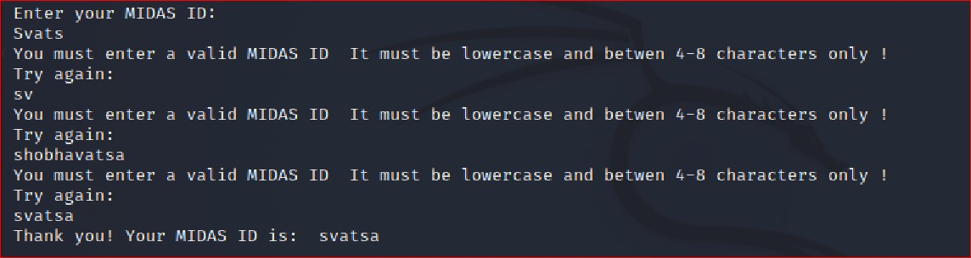

# Task B (Correct script (25 points) + result/output after executing the script (25 points) - Create a new directory

Write a shell script like below, that performs the following task:

1. **Reads** the name of the directory.
2. Check whether the given input is a directory or regular file.
3. If the input is a directory and exists, then display the message “Directory exists. Do not create”.

a. **(Extra credit: 10 points)** Display the contents for that directory)

1. If the input is a regular file, then display the message “It is a regular file. Do not create”.
2. **If the given input name in step-1 doesn’t exist**, then create the new directory with the given name in step-1.

(Sample screenshot for executing the script is shown below)

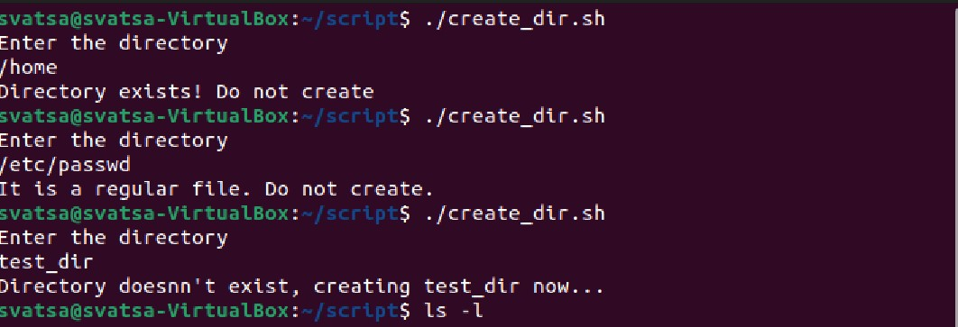

**Extra Credit(15 points**)- Check files

Write a script like below that

1. Gets the name of the directory as input.
2. Your script should check for the validity of the given directory name, if the entered filename is a directory or and pop out an error if an invalid directory name is entered.
3. You need to execute your script and test the following directories with your script (sample screenshot for executing the script is shown below in the screenshot):

* **/etc/systemd**
* **/home**
* **A directory that does not exist**

Display the contents for the directories you have entered (See the screenshot below)

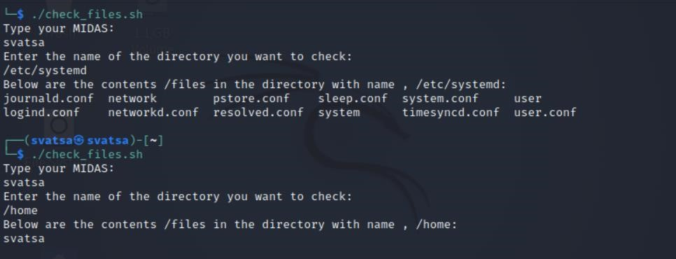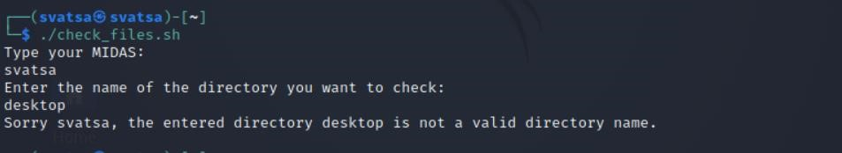

Please note:

Each student needs to screenshot your source code and the output after executing the script.