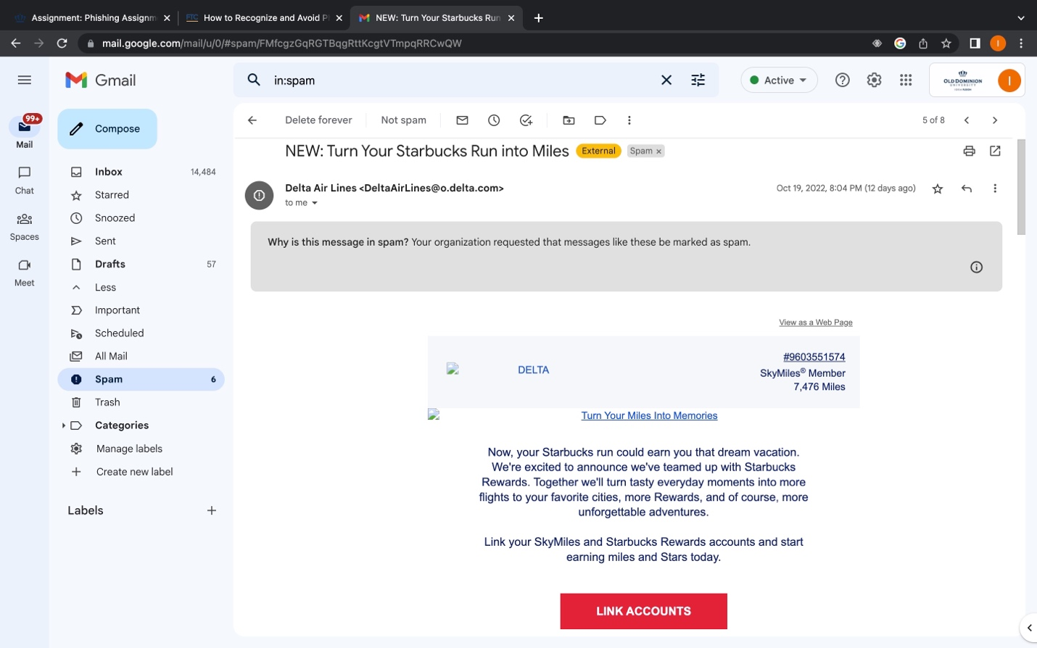

I wasn’t too sure if this was a correct example or not because I haven’t had a phishing issue before However, I was able to locate this email and there are a couple of reasons why I thought of this as an attempt to breach my system. I don’t know why I have delta emails because when it comes to flying that is normally what my mom does, and I don’t use delta in any way. That was my first concern and my second one was the link that was on that email. I’m not sure what would happen if I clicked on it so I find it best to delete it or just not even pay it any mind at all. Also, the Starbucks prize can be just another tactic to get me interested in what they have to offer.

