William Ramlatchan
Understanding Media
Dr. Kyle Nicholas, Ph.D
December 2, 2022

Personal Media History:
The Only Metaverse Contender

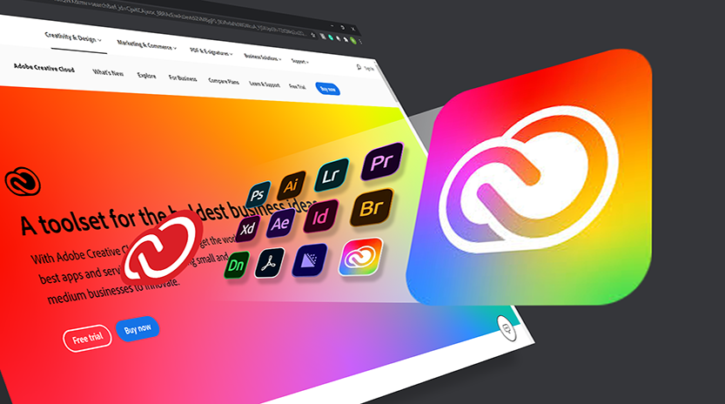
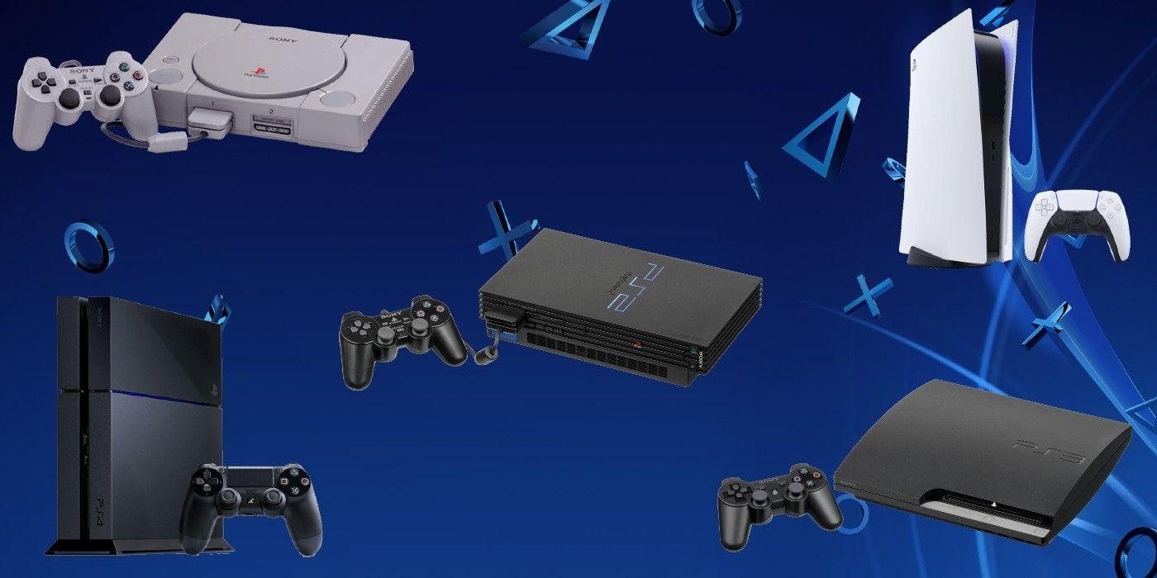
Since I was born at the beginning of the new century and the start of the modern technological age, I would be growing alongside the latest emerging technologies. However, rather than having a sudden shift like the previous generations before me, my mom still has trouble with computers to this day. On the other hand, I got to experience and try out new technologies and media since they were so accessible and plentiful at a young age, so I quickly found out what I did and didn't like. Naturally, I dabbled in Sony products, such as playing on numerous Playstations with my family. Tinkering with Apple and Google to fix or improve them, helping my dad set up most of his Amazon products. I have experience with software such as Photoshop, Maya, and CAD, from programs in school to playing hundreds of video games in my leisure time. However, one video game stood out to me the most for its versatility and variety—a 2017 game developed by Epic Games: Fortnite.

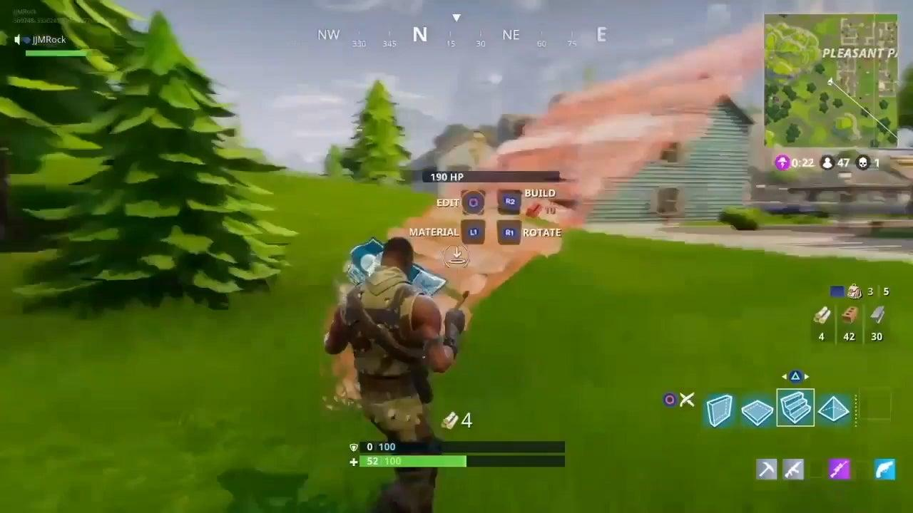
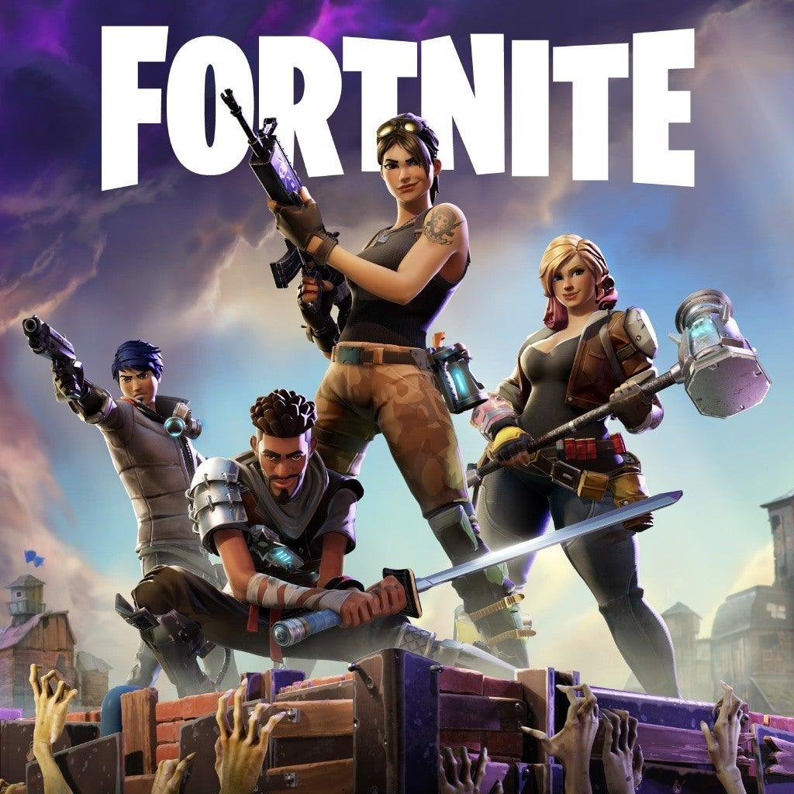
Fortnite has grown exponentially in popularity over the past five years. However, it is much different from its roots in 2017, where it was a simple Player versus Environment-style game. Fortnite is the umbrella term for the game, the stylish exterior of a well-oiled media machine that anyone can use. Fortnite has three main game modes: Save the World, Battle Royale, and Creative. Now for this article's sake, I will mainly focus on Battle Royale and Creative. I enjoy Fortnite and have used all three modes for countless hours, so that I will add my unique input alongside my analysis of the subject.

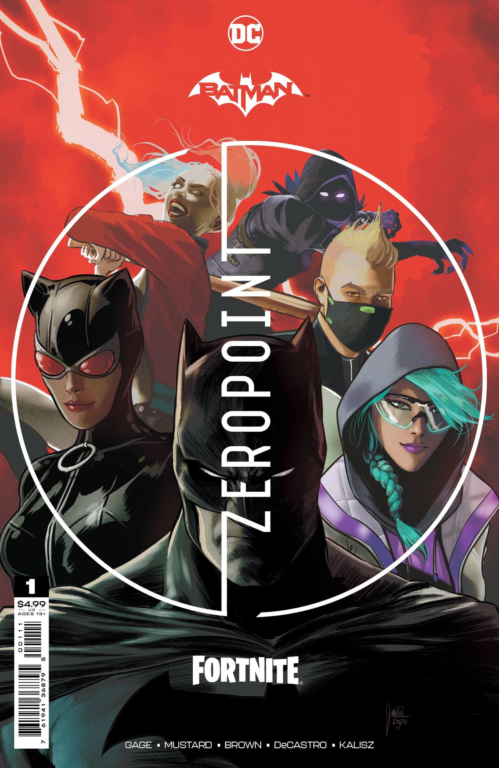
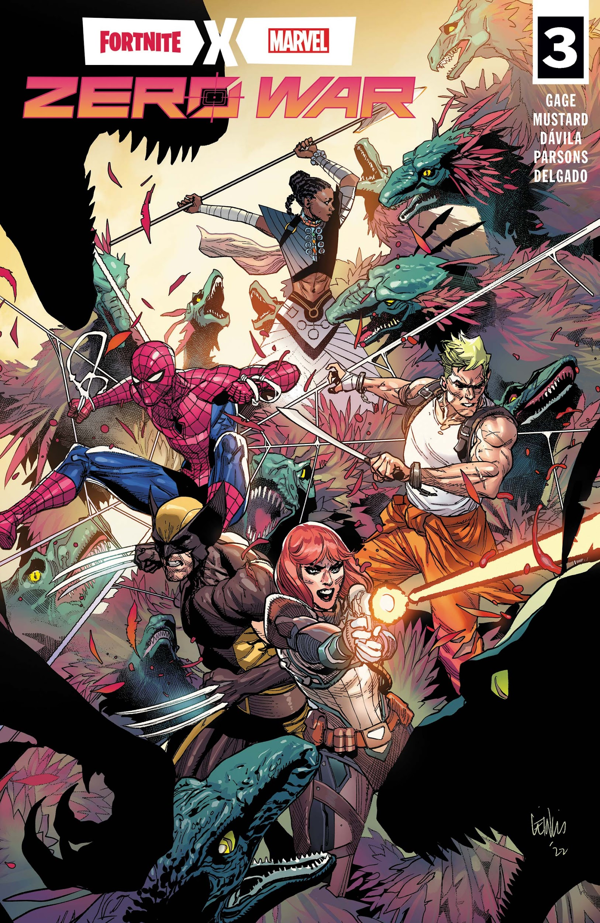
Fortnite in 2018 swept and engulfed the world by storm, spiking in popularity to tens of millions of players around the globe. Although Fortnite's main selling point is its battle royale gameplay, that is just the surface-level experience, the last one standing and you win. However, if you keep playing and completing challenges in the game, you gain more and more insight into what's going on in this seemingly simple video game. The underlying story is an always-evolving tale about power, corruption, war, and survival. Fortnite goes as far as to create comic books to expand the story further. Similar to the print culture, appease that crowd that wants a physical narrative and item discussed in Modules 2 and 4 . Instagram can't do that, nor could Twitter, but this little video game can do it. Also, because Fortnite has been around for so long, the story can use nostalgia to move us as the fanbase emotionally. It is using its past media in the present to pull at our heartstrings.

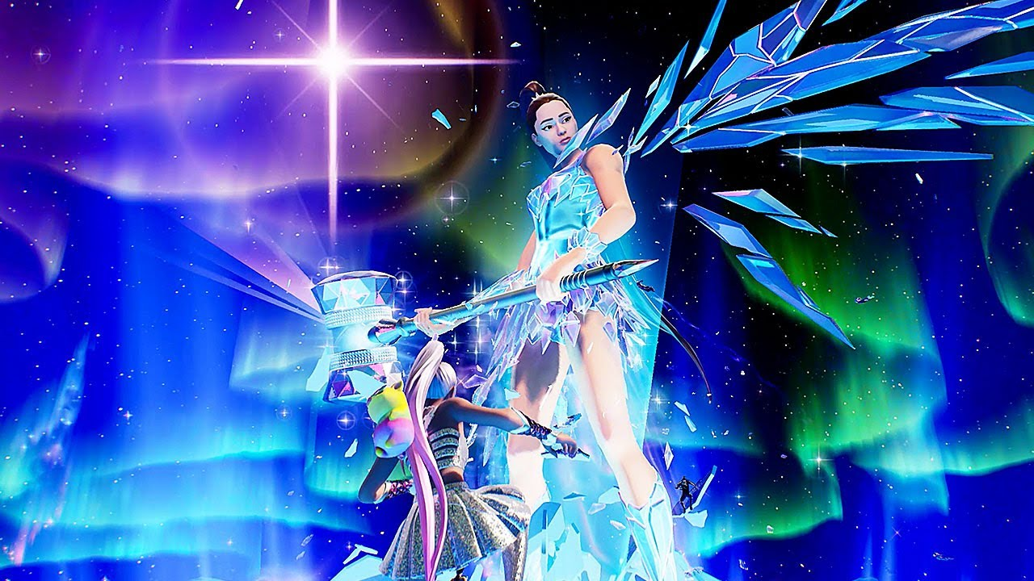
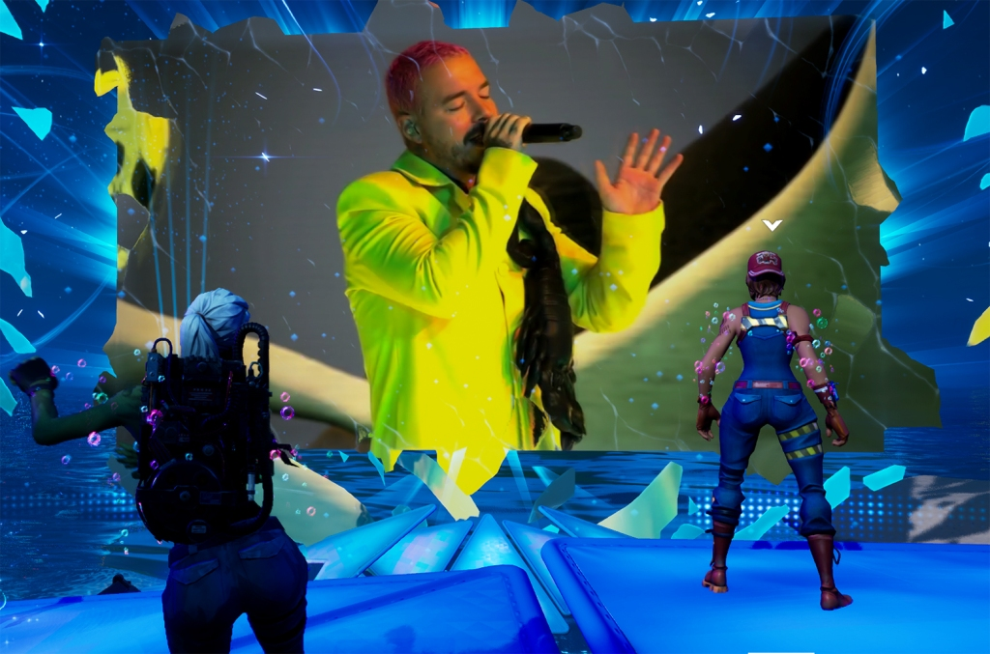
Storytelling aside, Fortnite has also done things to get us emotionally invested, emotional in general. Fortnite used its media and power to bring joy to its player by being one of the first games to establish virtual concerts. Live events within its game to accommodate for the shows that had to be canceled or postponed because of the pandemic—collaborating with artists like Travis Scott, Ariana Grande, J Balvin, Marshmallow. Using its game engine, the Unreal engine, to create a virtual interactive experience for both players of its game and fans of the artist that the event is featuring.

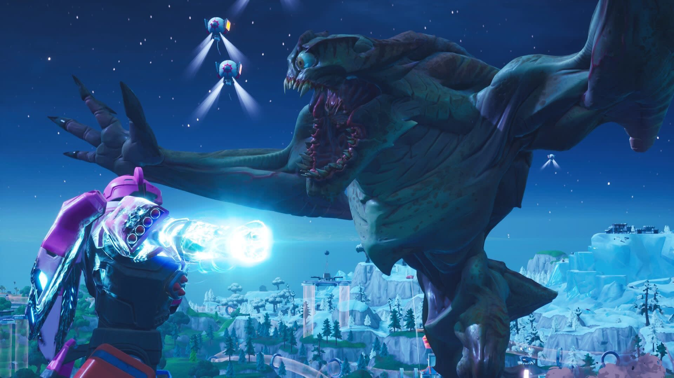
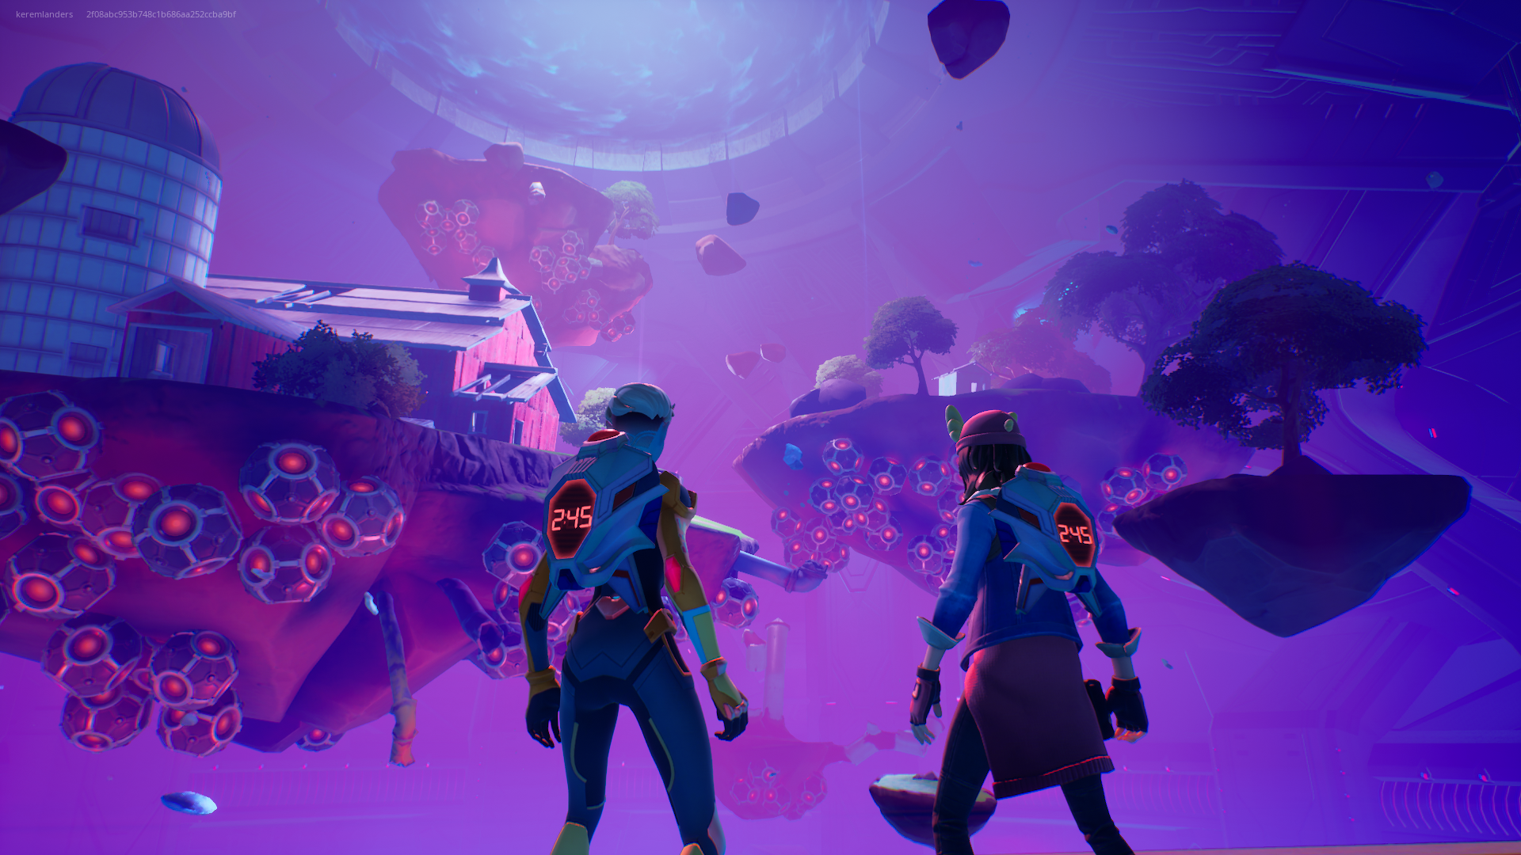
Besides the apparent participation in constant one-hundred-man matches with people worldwide, Fortnite is much more than that. Similar to its in-game virtual concerts, Fortnite has events to end its seasons. Identical to how mass media allows everyone to experience something at the same time, these events are similar to that. These one-time events help push the emotional roller coaster that is the Fortnite storyline.

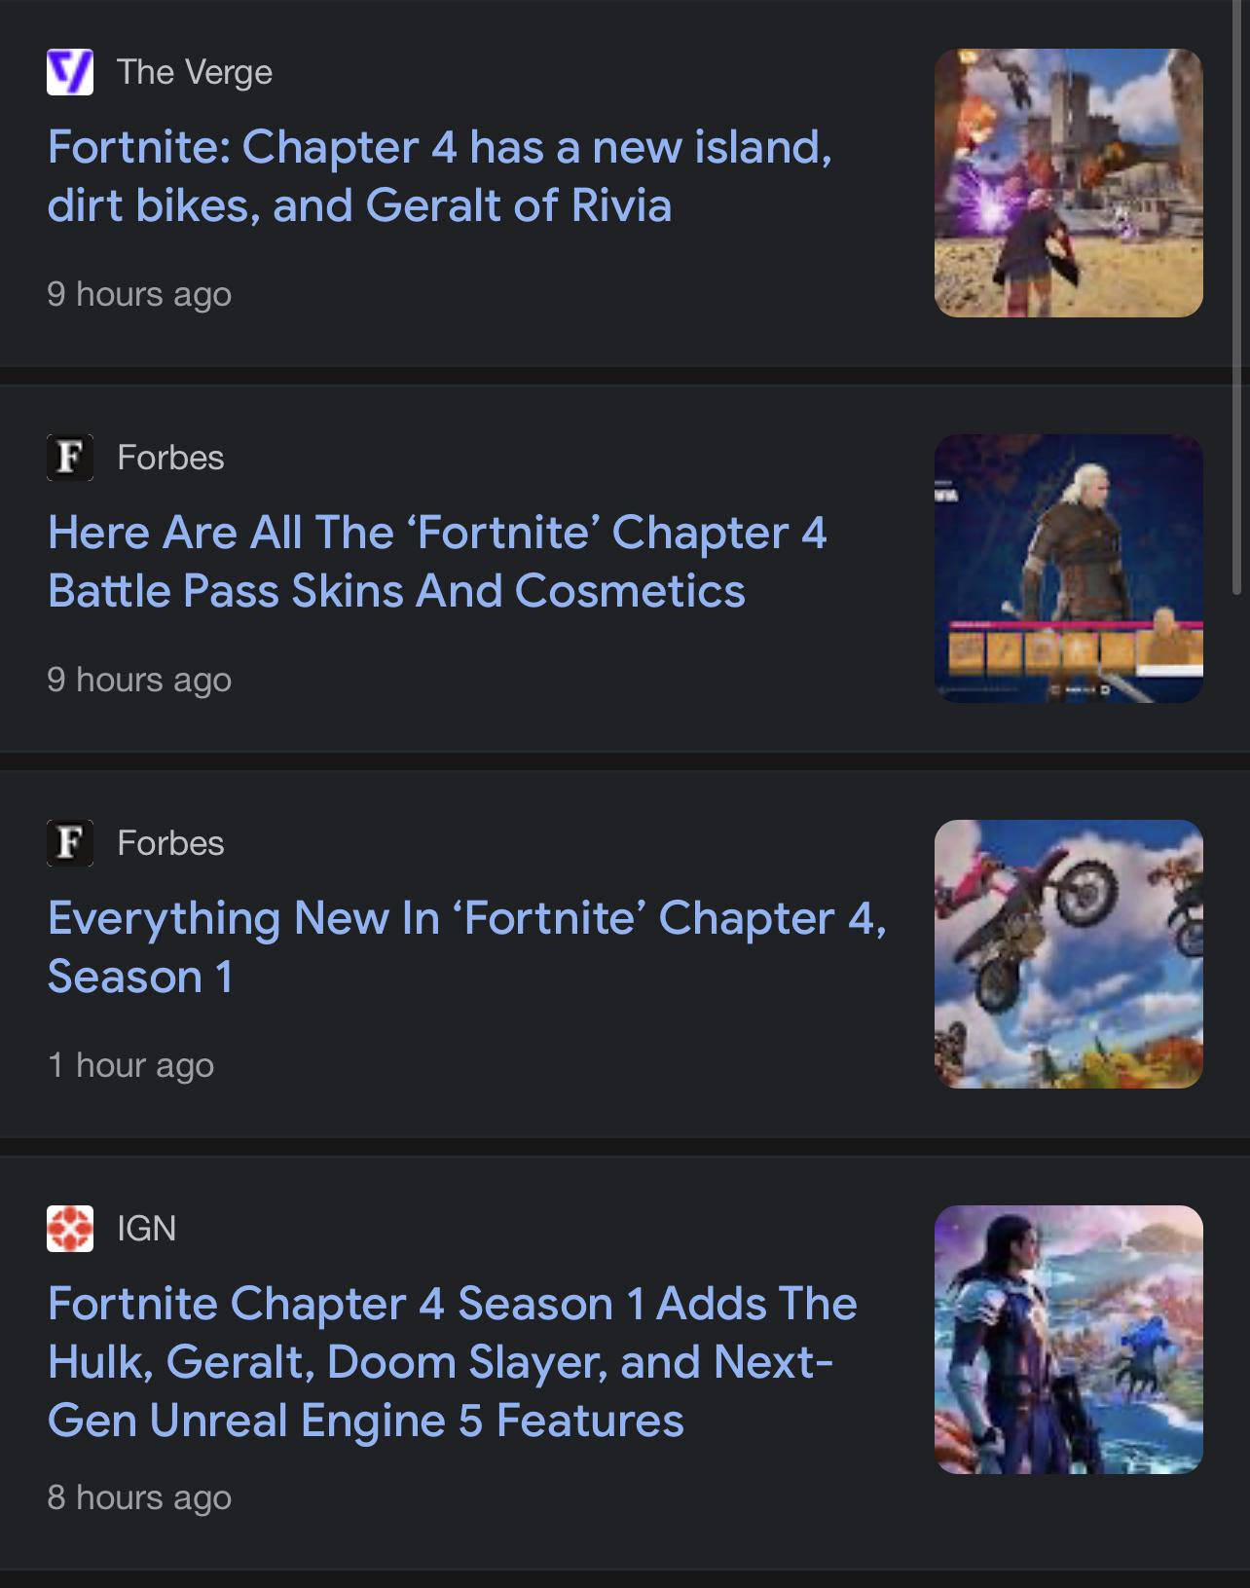
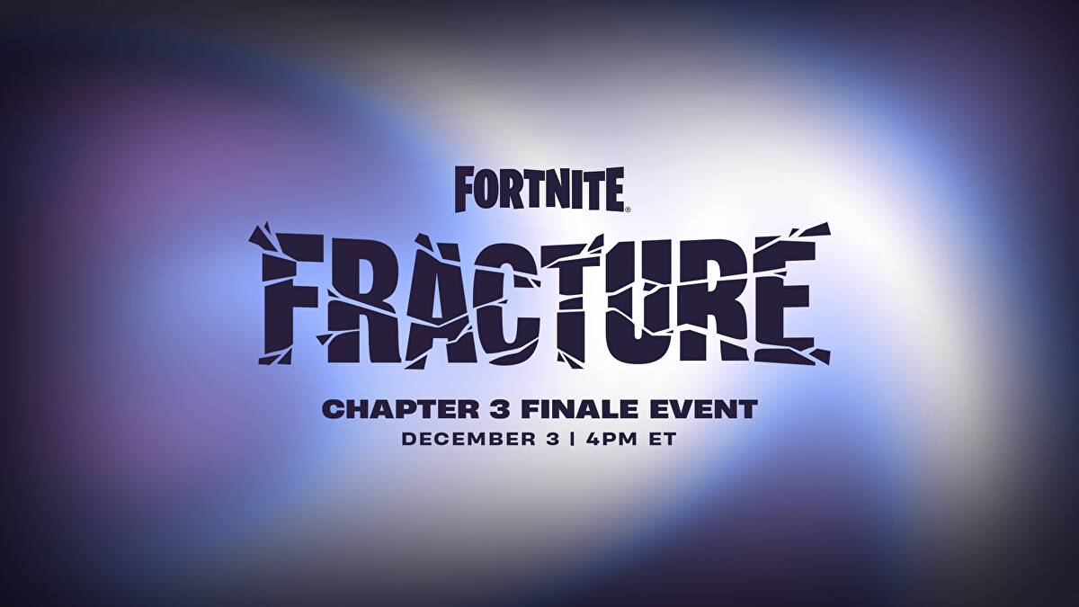
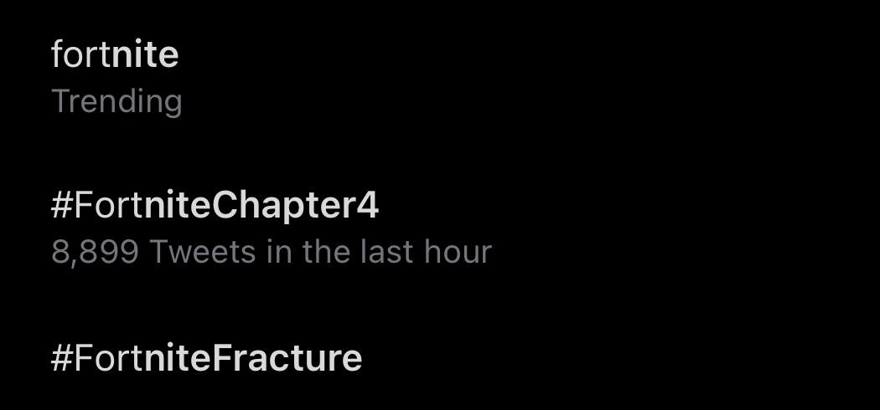
As of typing, Fortnite just had an in-game live event where millions of players gathered to watch as the main story continued. Creating an interactive experience in which we, as the player, participate in the events of the storyline—simulating a very immersive, emotional experience while also being completely free. Its newest event brought a new Chapter and Geralt from the Witcher.

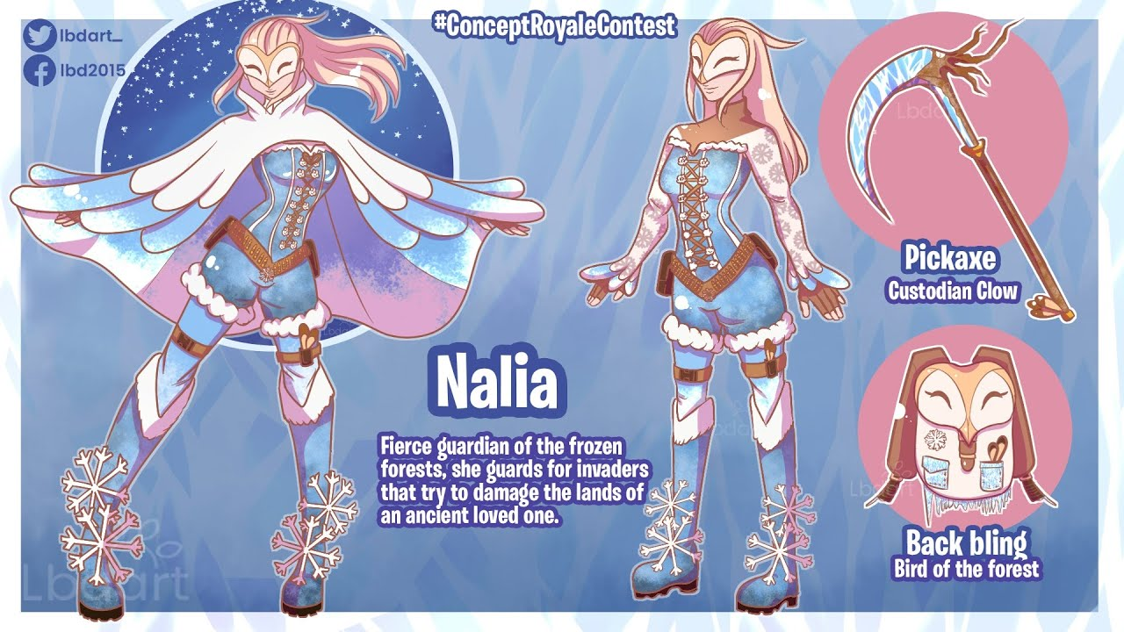
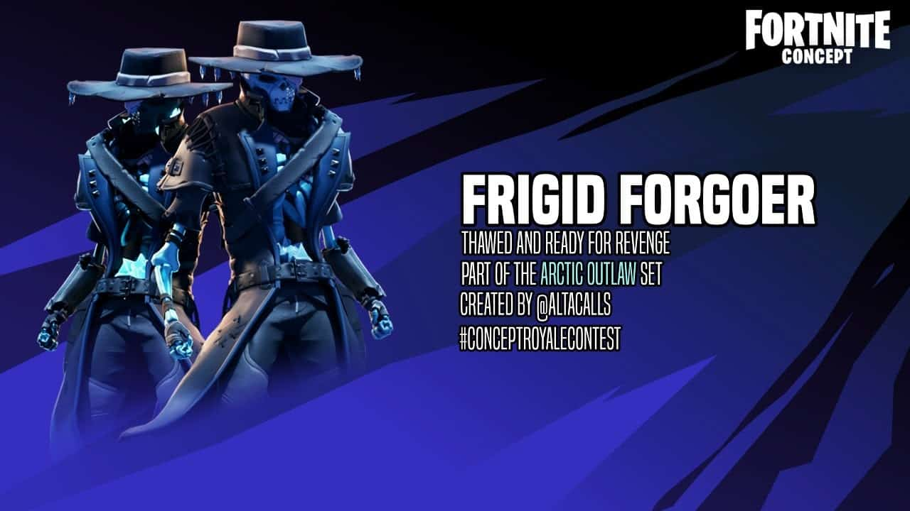
Every so often, Fortnite hosts a challenge for fans and creators to make content for the game, an instance where a company is getting fresh ideas and content from the different perspectives of the players. These challenges often involve contests to design/ create something that contestant-made skins would put in the game. For example, fans could create an in-game spray, emoticon, or their skin to be put into the game. This year’s design contest entries was a winter wonderland, and these were the two skins that were chosen by the community to be put in the game, both skins completely different from one another based on a “winter wonderland”.

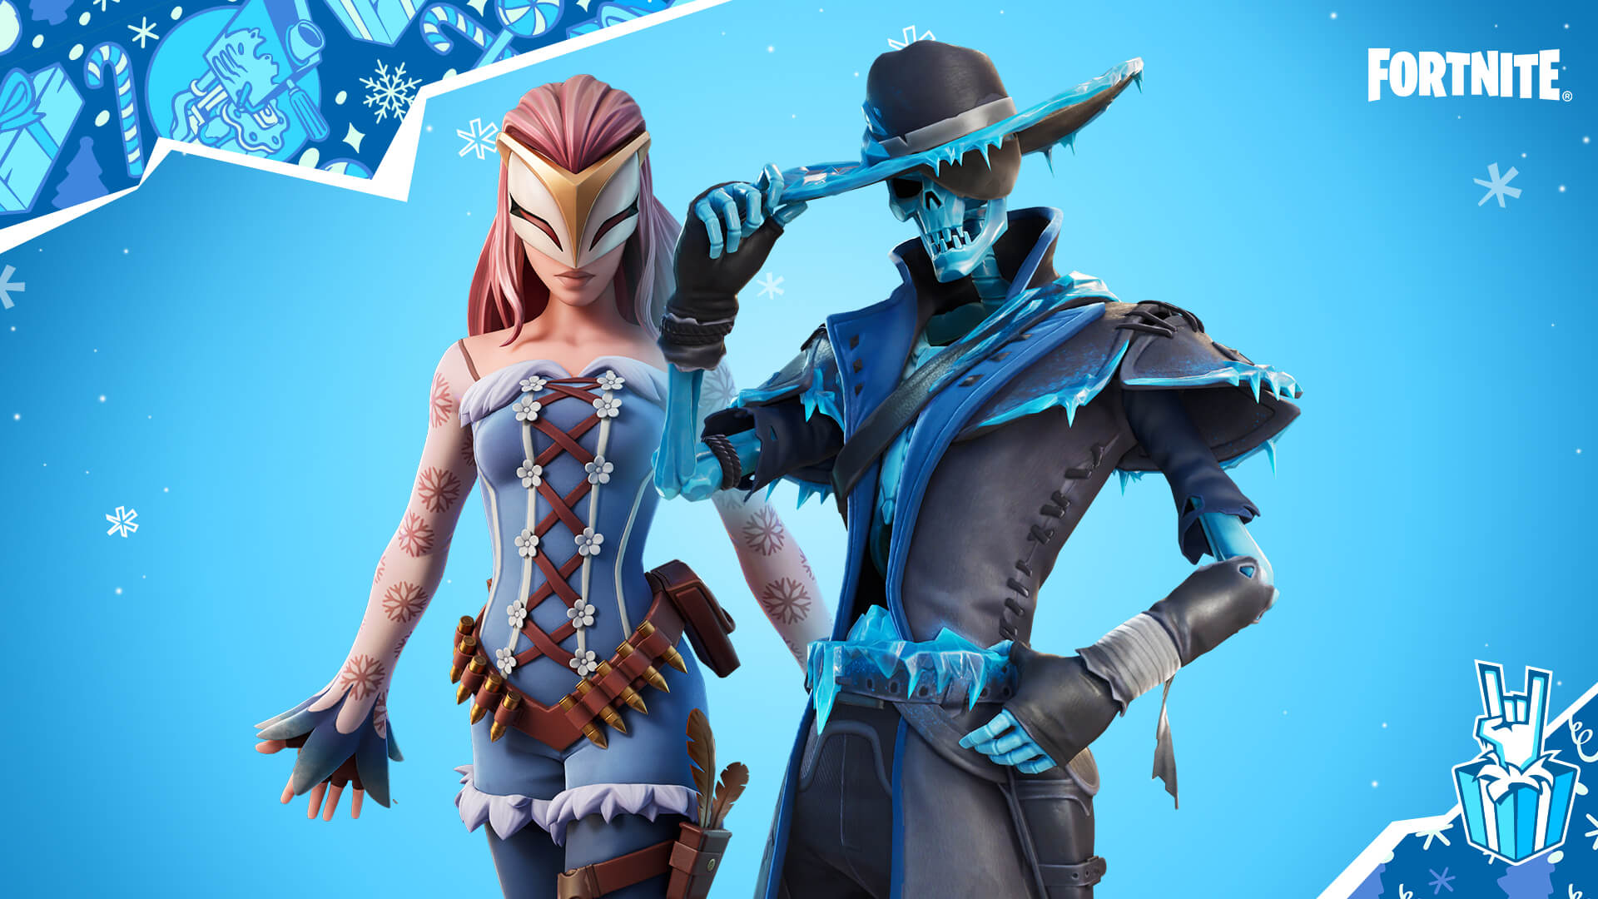
Fortnite would give fans a simple prompt, which as an artist, means that the outcome could have all sorts of variations from artist to artist. And once your entry is complete, the contestant will post their design on social media for the masses to see and vote. So even if you feel you need more confidence to create a skin or aren't artistically inclined, you could still participate in the contest.

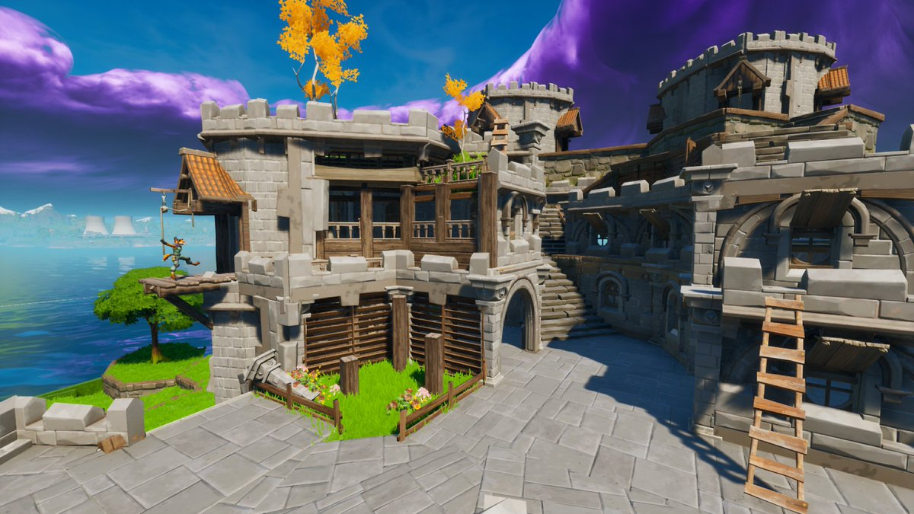
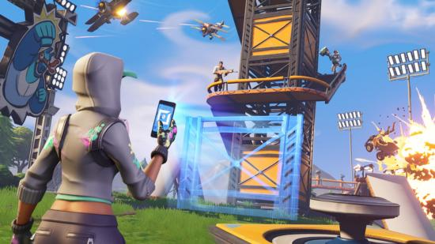
I'm not saying a single video game made me want to turn over a new leaf and change my life for better or for worse, but it greatly influenced my decision-making for my realm of study and desired career path. I'm also assuming that the same influence affected other people by observing how the game increased in quality and popularity. Fortnite's creative mode is the first step example to being integrated with the game since the Creative mode allows you to use the game's assets to create and publish custom maps and game modes anyone can use around the world.

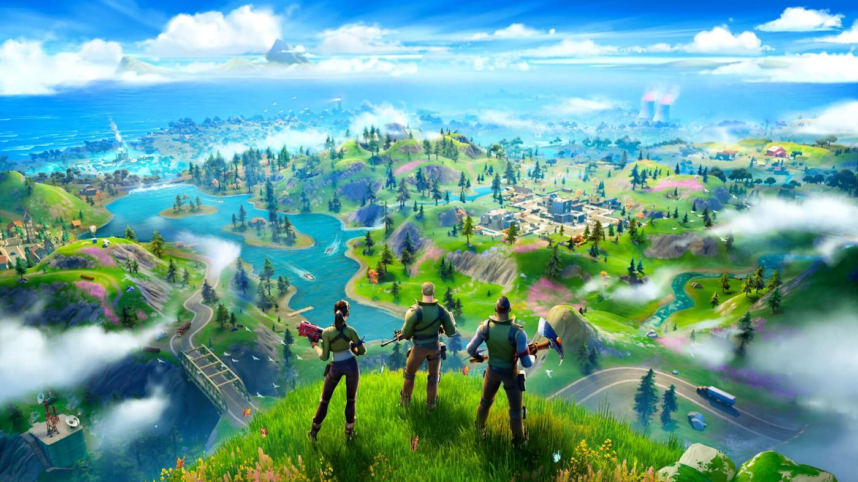
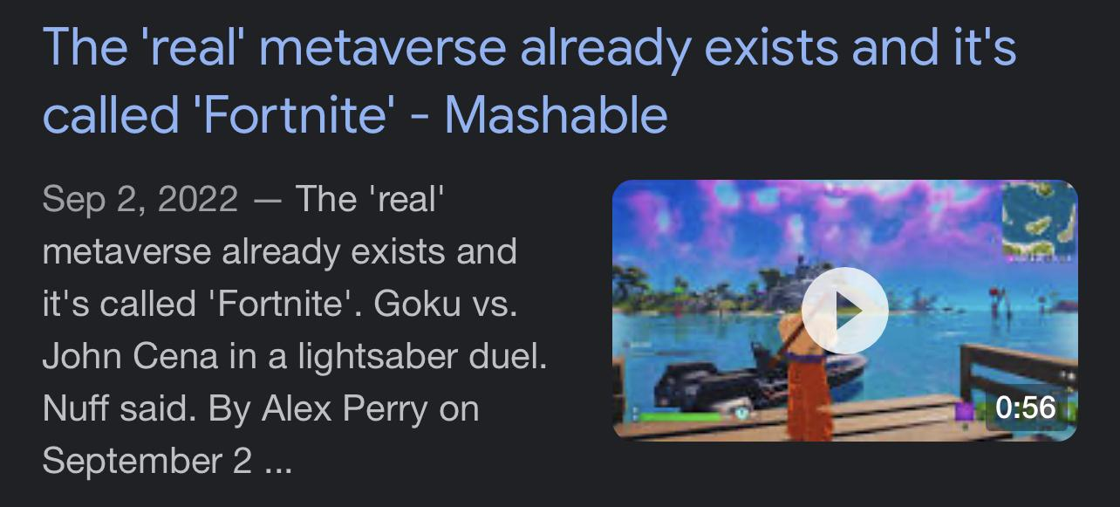
In terms of media, Fortnite became a multimedia powerhouse with collaborations and connections with just about everything—allowing its community of players to use and mold the same assets as Epic games employees. Fortnite has become special since it can bring battling companies together to collaborate. Watching this game become a tool for enjoyment and engagement has been a rollercoaster. Fortnite has the same versatility and variety as a virtual reality machine and is free of charge. If the fictional world of the Metaverse, no, not the one Mark Zuckerburg is trying to create, the one from Ready Player One, were honest, Fortnite would be the most significant step in that direction. It amazes me how a video game about to fail has made one of the most significant U-turns in media history and become one of my favorite forms of entertainment and media.

